**3D Boho Bull Head Skull**

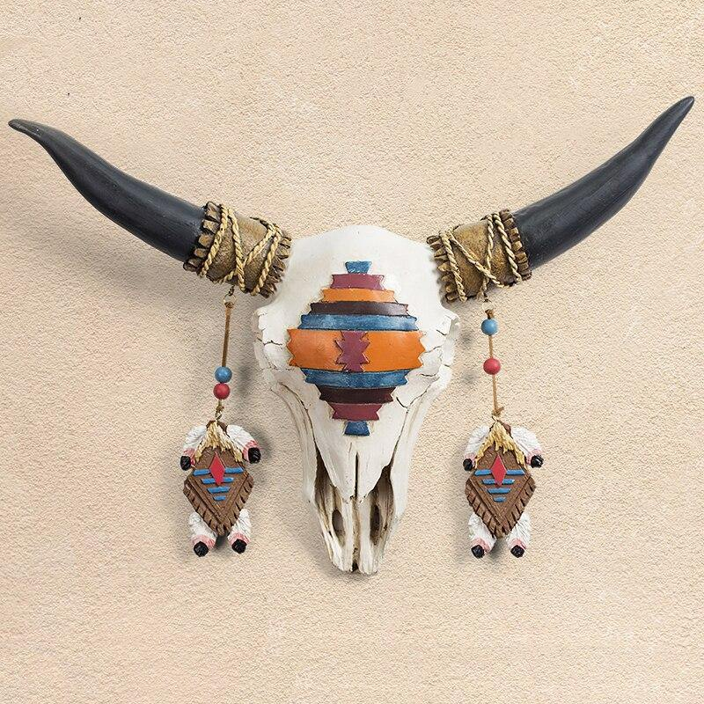The 3D Boho Bull Head Skull is a captivating and eclectic wall decor piece that blends rustic charm with bohemian flair. Designed with intricate detail, this bull skull features bold, stylized horns and ornate patterns that evoke a sense of free-spirited adventure and earthy elegance. The three-dimensional construction adds depth and texture, making it a striking focal point for any space. Whether placed in a living room, bedroom, or eclectic gallery wall, this unique piece brings a sense of wild beauty and artistic expression to modern, boho, or southwestern-inspired interiors. Its distinctive design and natural, earthy aesthetic make it an eye-catching statement for those looking to add character and personality to their home...